CS 340 README Template

About the Project/Project Title

This Python CRUD project is meant to give a way to manipulate data in a MongoDB by using the CRUD principles of Create, Read, Update, and Delete. This project is a Python module that can be used alongside of scripting to make a powerful tool for data manipulation.

Motivation

This module is being currently used to manage a database for the AAC animal shelter to show different information about intake and outtake of the animals. The reason we are creating this project is to make sure that it is more simple and accurate to keep track of the different animals in the system.

Getting Started

To get started you must first download the PythonCRUD.py file into a text editor of your choice. You must have access to a MongoDB to run the script and also you need to set up a Jupyter Notebook instance to use for scripting. It will also help if you are familiar a little with the bash tool pip, to make sure that you have the correct libraries installed to utilize this project.

Installation

- Python: Make sure to have Python installed on your system. You can download Python from https://www.python.org.
- MongoDB: Install MongoDB on your system. Follow the installation guide on https://www.mongodb.com.
- PyMongo: Install the PyMongo library using pip: pip install pymongo
- Jupyter Notebook: Install Jupyter Notebook using pip: pip install notebook

Usage

Code Example
From the PythonCRUD.py file:
# Create method for the C in CRUD
def create(self, data):
if data is not None:
try:
self.collection.insert_one(data)
return True
except Exception as e:
print(f"An error occurred: {e}")
return False
else:
raise Exception("Nothing to save, because data parameter is empty")

# Read method for the R in CRUD
def read(self, query):
if query is not None:
try:
cursor = self.collection.find(query)
results = list(cursor)
return results
except Exception as e:
print(f"An error occurred: {e}")
return []
else:
raise Exception("Query parameter is empty")

Tests
Describe and show how to run the tests with code examples.

An example of a possible script:

from PythonCRUD import AnimalShelter
shelter = AnimalShelterI()

# Test the create method
animal_data = {
“name”: “Buddy”,
“age”: 3,
“species”: “Dog”
“breed”: “Beagle”
}

insert_success = Shelter.create(animal_data)
print(f”Insert successful: {insert_success}”)

#Test the read method
query = {“species” : “Dog”}
animals = shelter.read(query)
print(“Query results: “)
for animal in animals:
print(animal)

Screenshot

#Import aac_shelter_outcomes.csv
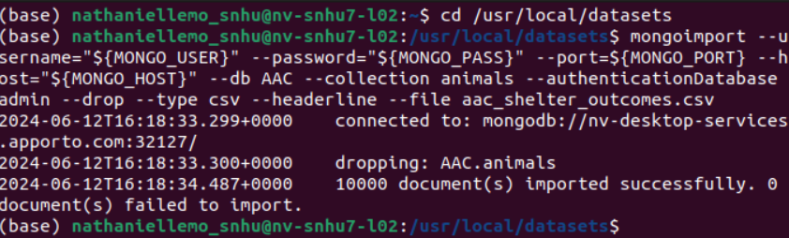

#Login to MongoDb Shell
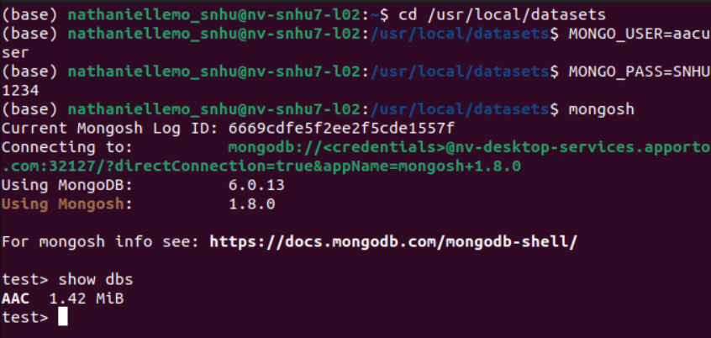

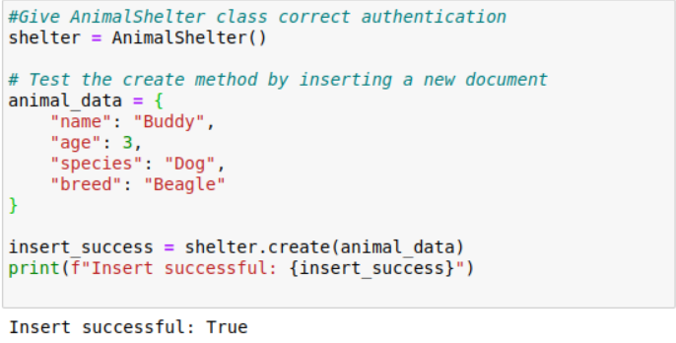
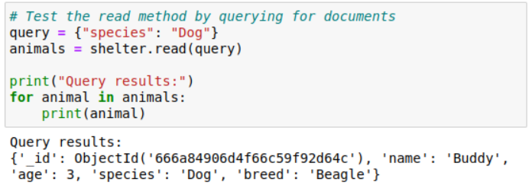
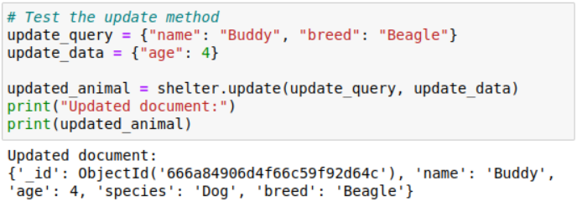
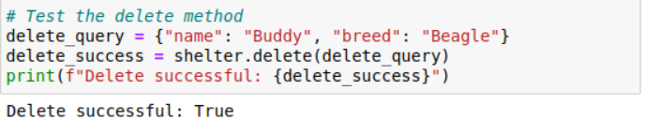

#Final Product

#Original

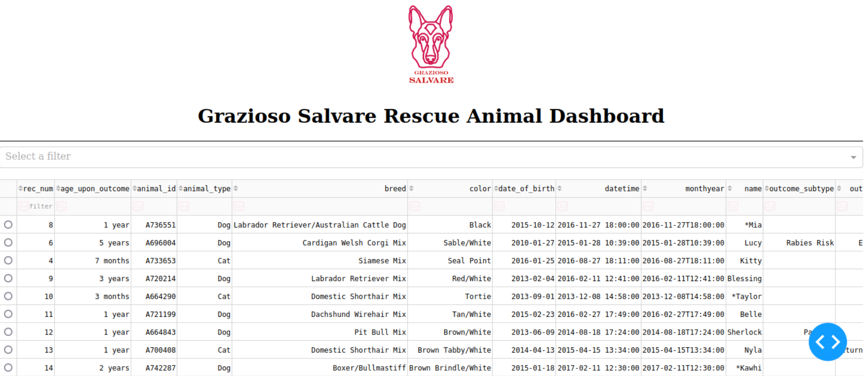
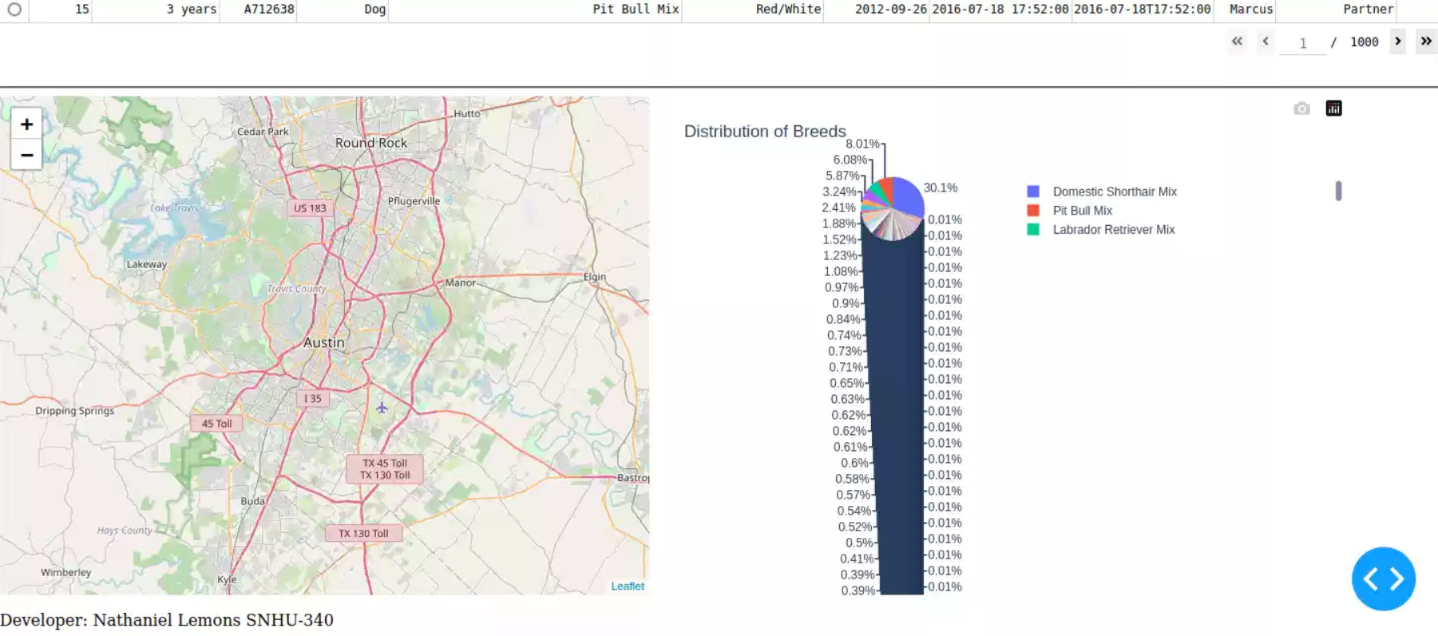
#Water Rescue

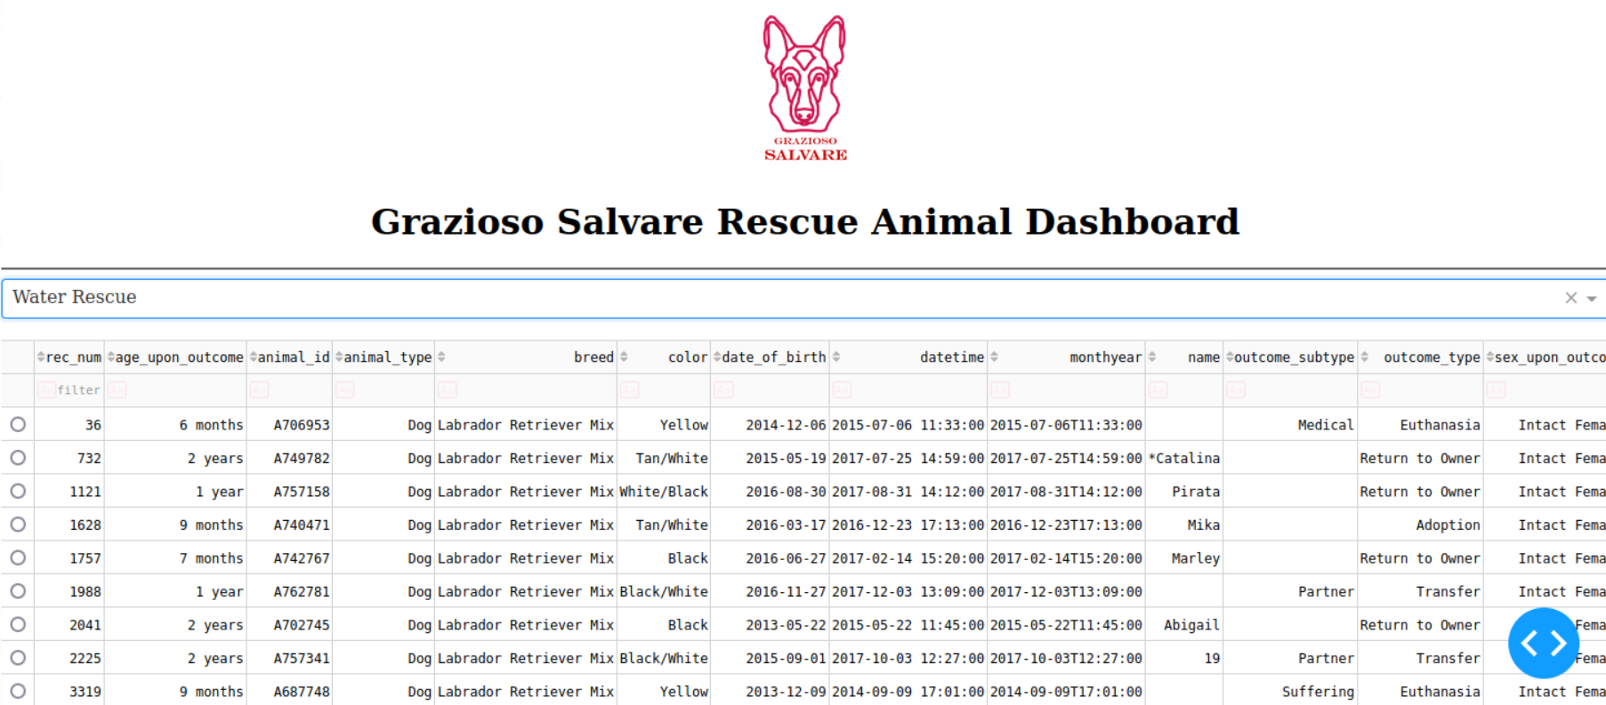
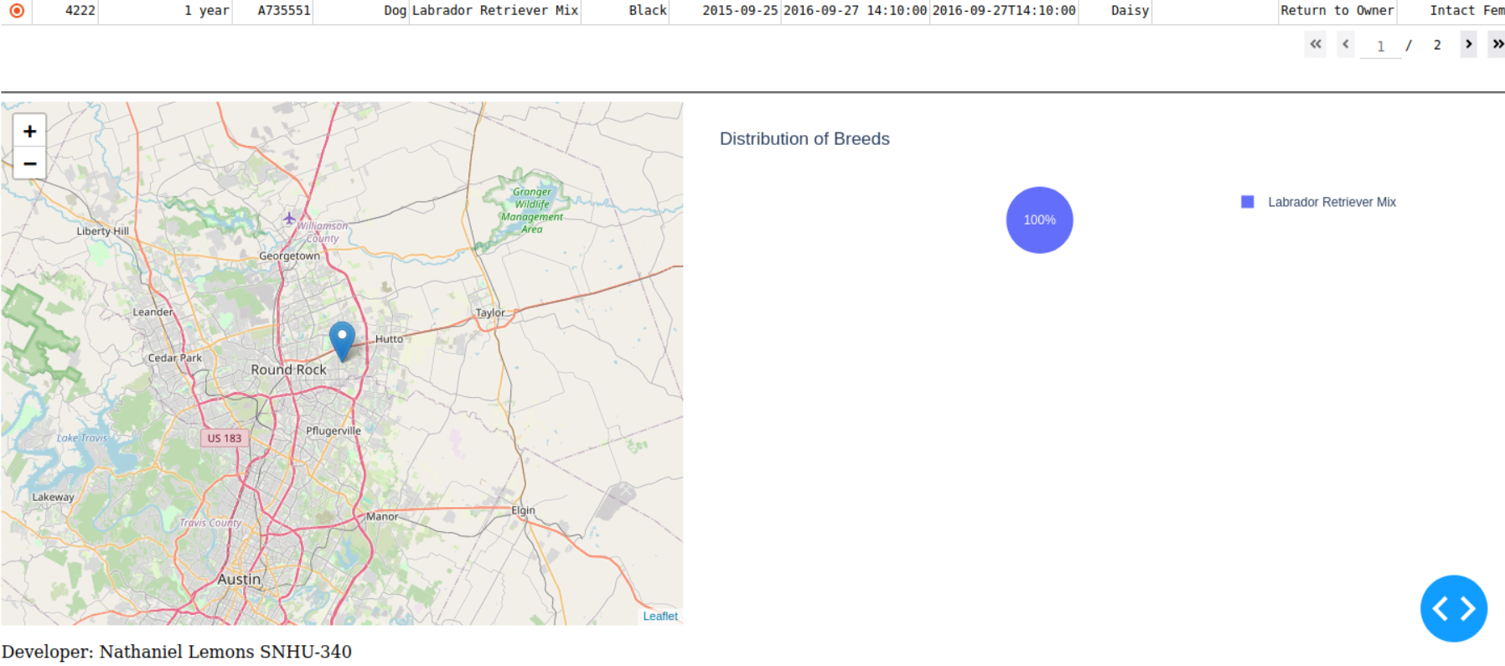

#Mountain or Wilderness Rescue
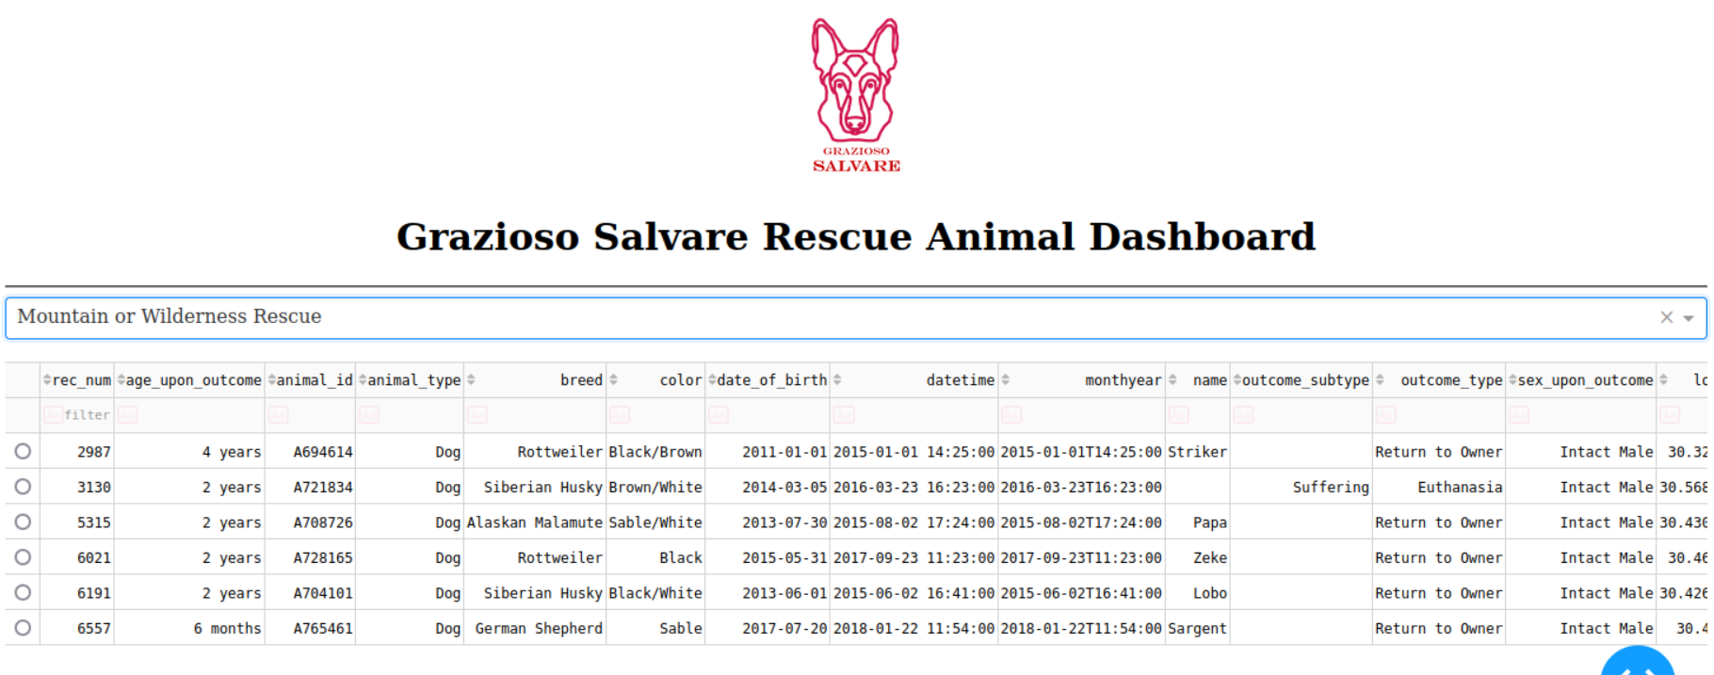
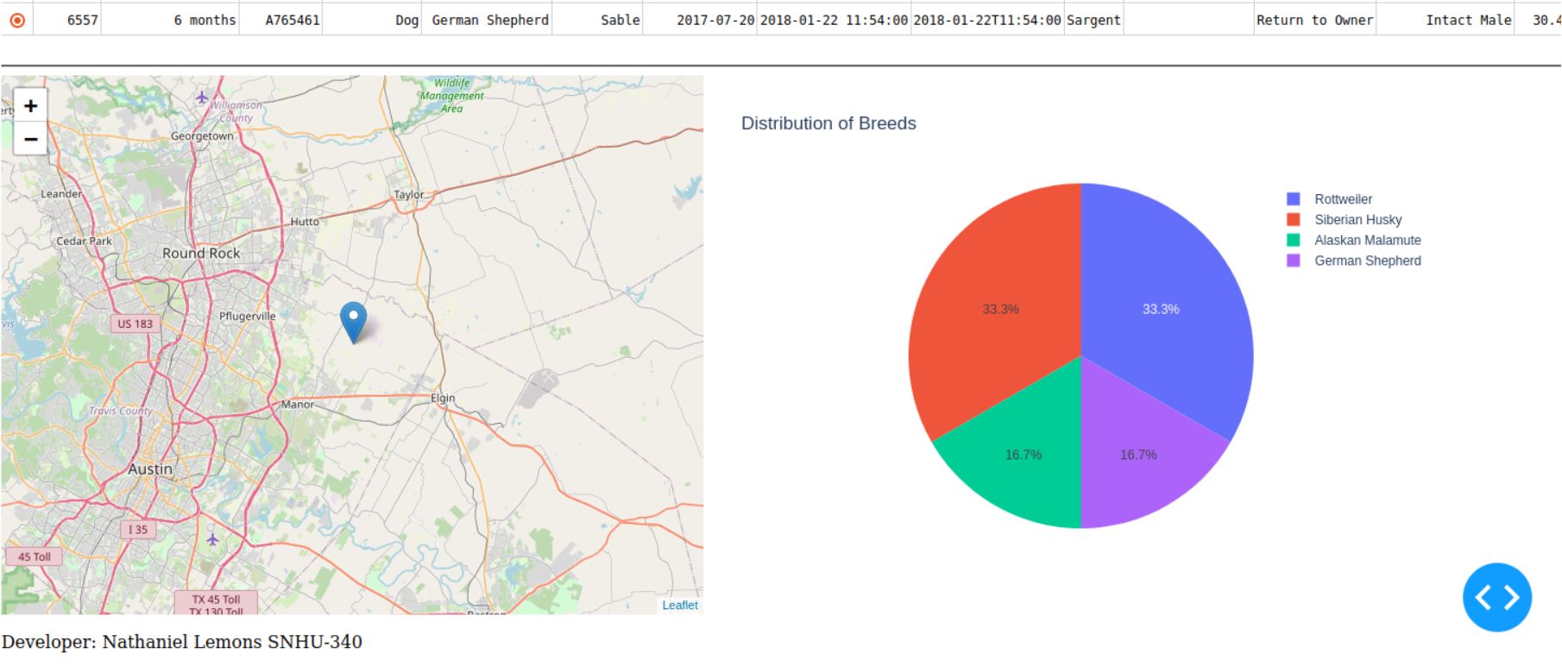

#Disaster or Individual Tracking
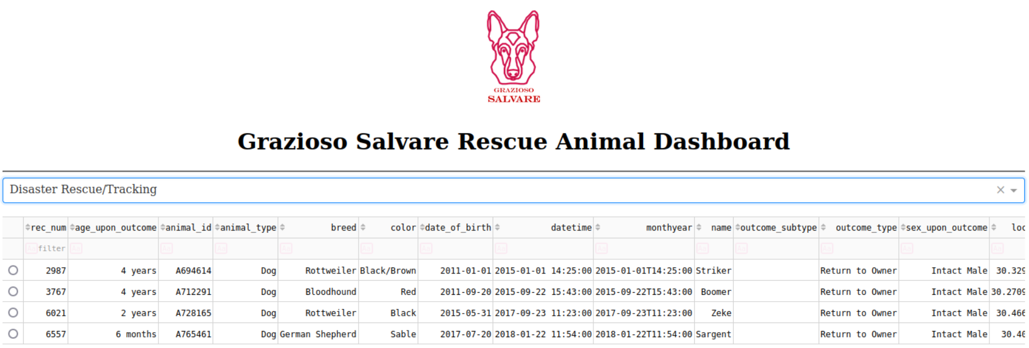
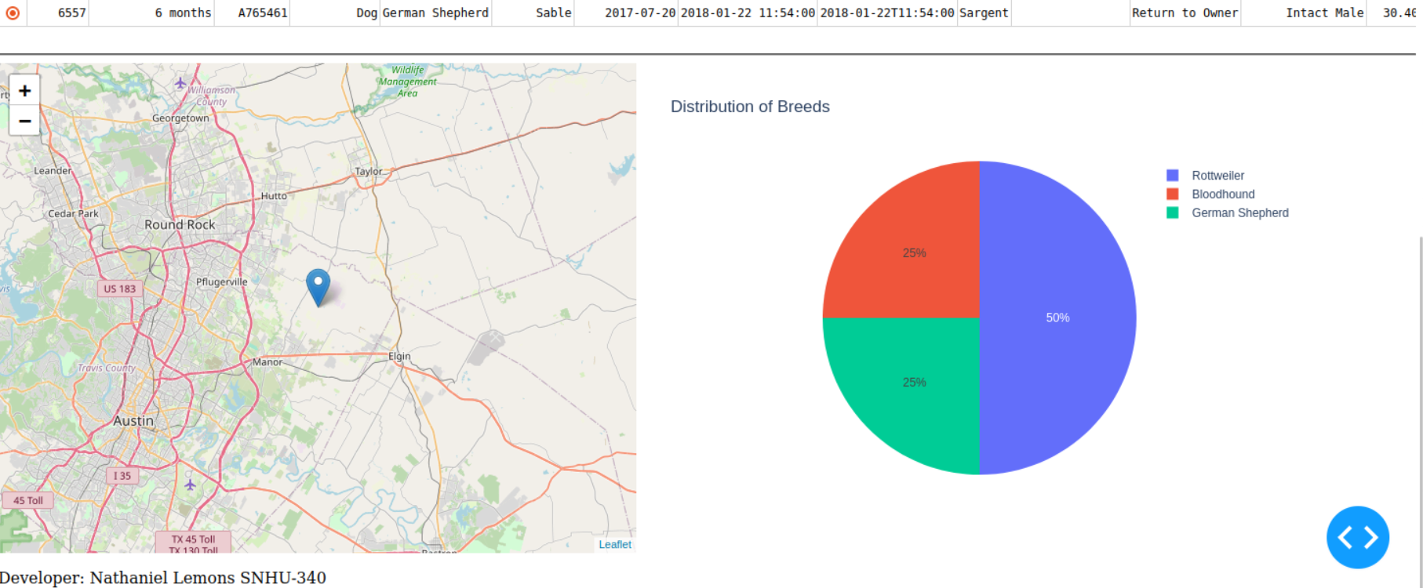

#Reset
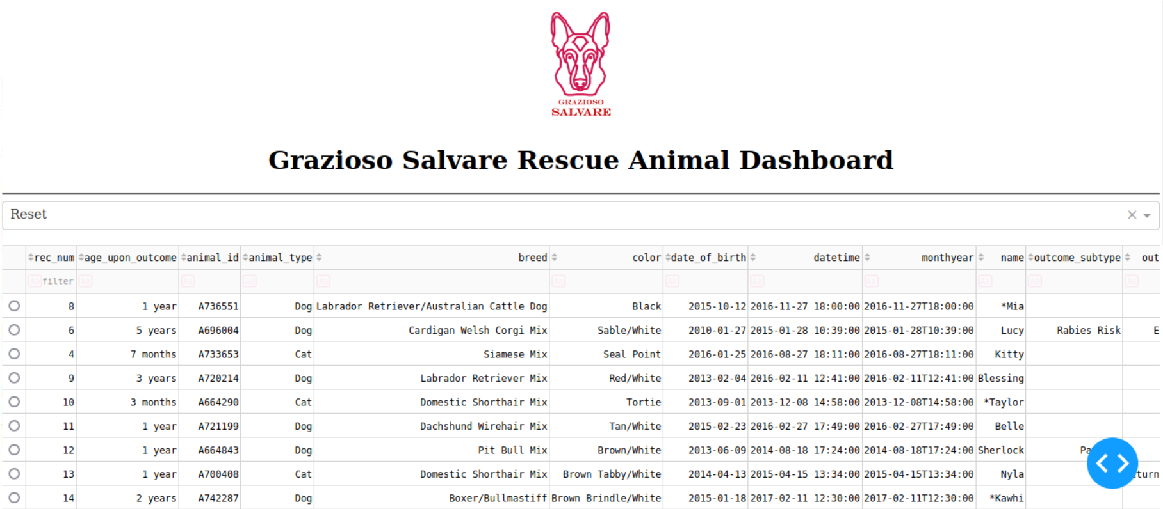
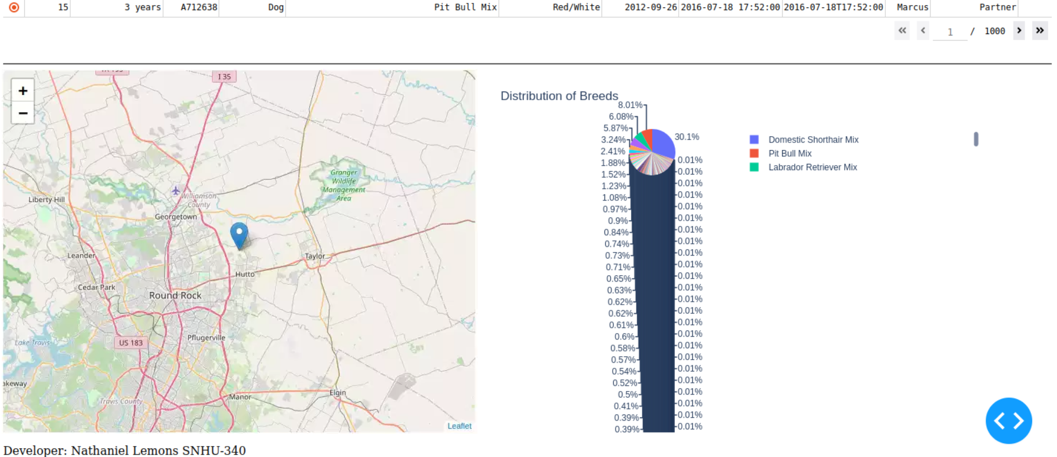

Contact
Your name: Nathaniel Lemons

